PROJECT TITLE : NOISE POLLUTION MONITORING

PHASE :3 : DEVELOPMENT PART -1

OBJECTIVES:

The increasing air and sound pollution is one of the significant issue now days. As the pollution increasing it is giving rise number of diseases so, it has become essential to control the pollution for better future and healthy life .here we propose an air quality as well as sound pollution monitoring system that allows us to monitor and check live air quality as well as sound pollution monitoring in particular areas through IOT . System uses air sensor to detect or sense presence of harmful gases, compounds in the air and constantly transmit data to microcontroller. Also system keeps measure sound level and report it to the online server over IOT. The user friendly and easy handling of the system technology is such that it can be installed in houses, schools and in small places. KEYWORDS: AurduinoUno Gas Sensor MQ135,Sound Sensor LM393,Wifi Module

WOKWI :

Wokwi is a versatile online platform that allows you to design ,simulate, and test electronic circuits in a virtual environment.

ore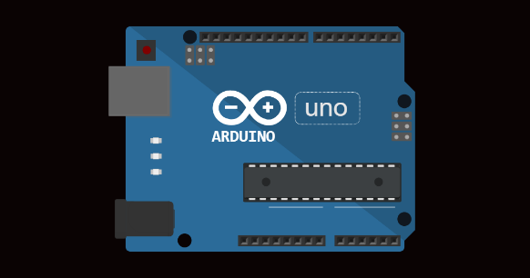

Website (<https://wokwi.com/arduino>)

Components Required :

1. Sound level meter(SLM)
2. Frequency Analyser
3. Microphone
4. Windshield
5. Data storage
6. GPS module
7. Calibrator
8. Data analysis software
9. Weather monitoring equipment
10. Continuous monitoring system
11. Remote communication
12. Power source
13. Mounting equipment

To monitoring noise pollution , you typically need a set of equipment and software to capture ,analyse and report sound levels .The above mentioned are some basis list of components required for noise pollution monitoring once you have these components ,you can set up a monitoring stations ,take measurements ,and analyse the data to draw conclusion about noise pollution in a specific area

Wiring connections

Sound level meter (slm):

Measures sound pressure levels in decibels (dB).It should comply with International standards such as IEC or ANSI specification.

Frequency Analyser :

To determine the frequency spectrum of the noise . This helps in identifying specific source of noise and the characteristics .

Microphone :

A specialized microphone that captures sound accurately and is manually part of the SLM.

Windshield :

A foam cover for the microphone to reduce the effects of wind noise during out door measurements

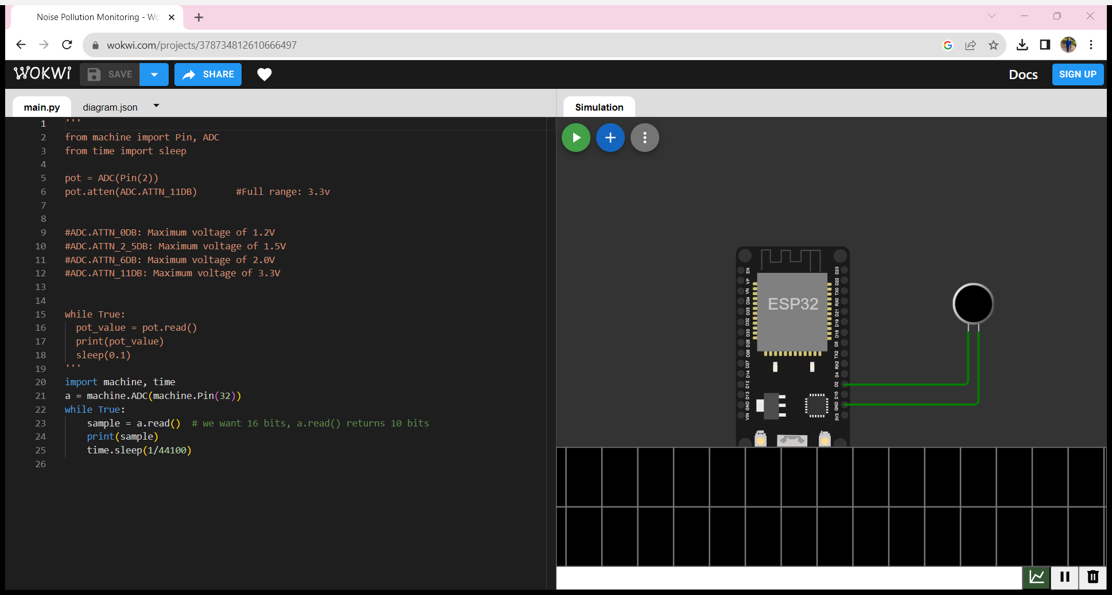

Code description :

Suppose the sound sensor sends an analogue voltage signal to Arduino’s analogue pin ( A0) . This voltage is representation of ambient noise .

Int sensor Pin =A0;

Output

Int sensor Value =0;

the sensor

int threshold =512;

void setup ()

{

Serial. Begin(9600);

}  
void loop()

{  
sensor value=analogue Read (sensor Pin);

From the sensor

Serial .print ln(sensor Value );

If (sensor value>threshold)

{

Serial .println(“high noise level!”);

}

Delay(500);

}

Result Analyse

This project aim to create a noise pollution monitoring using Wokwi , integrating

a sound level or a compatible microcontroller with virtual components such as microphone ,frequency analyser ,wind shield . The simulation successfully monitors sound level ,causing the led to blink . This project show case the ability of virtual components to emulate the functionality of a real word system within a simulated environment .

conclusion :

This wokwi – based noise pollution monitoring simulation project effectively illustrates the control and monitoring of sound level using a sound level meter and virtual components . The project demonstrate the practicality of using wok wi virtual environment for hardware simulation , allowing precise testing and visualization of system functionality without physical components. The LED and sound stimulator responded to sound level changes as expected , showcasing the potential for virtual hardware modelling .